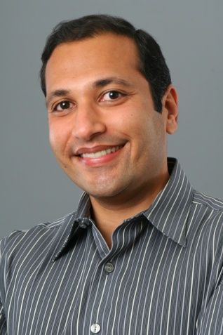
Tarak Modi

A Dynamic and Innovative Technology Leader
Tarak Modi is a seasoned IT executive and business leader, recognized thought leader, skilled enterprise architect, and well-published author. He has over 17 years of proven experience in achieving mission-critical results by leveraging IT for business value. Mr. Modi brings a unique combination of strong business and technical skills coupled with an excellent educational background that includes several industry-recognized certifications. This distinct combination serves as one of his most valued professional capabilities and provides a solid foundation for his diverse professional experience. As a testament to Mr. Modi’s industry thought leadership, he has authored Living in the Innovation Age (December 2011), co-authored Professional Java Web Services (January 2002), and published over 80 articles on topics such as Innovation, IT Transformation, and Enterprise Architecture. He is an excellent communicator with the ability to explain complex technologies to both technical and non-technical audiences. He has been invited to speak at several events on Innovation, Process Improvement, Project Management, and leading edge technologies such as Cloud Computing.
Mr. Modi recently held the position of Vice President and Chief Technology Officer at CALIBRE, an employee-owned Management and Technology services company. During this tenure, he served as the technology steward for the company worldwide to spur and promote the innovative use of IT. Mr. Modi led the planning and coordination of the company’s IT initiatives and implemented their first ever IT Strategic Plan within his first year at the company. He successfully led CALIBRE to achieve two “Gold” level competencies as a Microsoft Certified Partner, which provides $200K of tangible benefits annually. He provided technology and process leadership that was instrumental in CALIBRE achieving its CMMI Maturity Level 2 rating across its operating business units. The comprehensive corporate-wide audit program that he established resulted in Process and Product Quality Assurance (PPQA) being rated at CMMI Capability Level 4. He instituted and led quarterly Town Hall meetings to motivate and facilitate CALIBRE’s IT community of over 130 professionals to collaborate, share capabilities, and leverage improvements across the company. These Town Halls were recognized by the corporate management as a “key initiative” to fostering innovation within the company. In FY 2011, CALIBRE’s IT Community accounted for approximately 20% of the workforce and 25% of revenue.
Prior to joining CALIBRE, Mr. Modi has held senior leadership positions in several companies serving commercial, state & local governments, and Federal Civilian agencies. At Unisys, as Director of Technology and Architecture, Mr. Modi led the development of technology-related showcase content as part of a Six Sigma project to improve marketing effectiveness and efficiency. This effort resulted in the consolidation of over 60 client facing centers into seven centers worldwide with an annual cost savings of $7.6M. As part of this effort Mr. Modi established and led a 20-person offshore team to cost optimize portfolio and business development activities. As an Executive Architect (also at Unisys), Mr. Modi provided technical leadership on several proposals with an annualized value of $500M. His efforts were instrumental in improving the corporate win-rates on technology-focused proposal by 200%. Proud moments of Mr. Modi’s career also include a leading role on the F-22 stealth fighter plane program at Lockheed Martin and architecting an award-winning portal for the Georgia Department of Human Resources, Office of Child Support Services.

Mr. Modi holds a Master’s degree in Business Administration (MBA) from Georgia State University, a Master’s degree in Computer Engineering from The University of Alabama in Huntsville (UAH), and a Bachelor’s degree in Engineering from India. He has attained many prestigious professional certifications that include Certified Information Security Auditor (CISA), Certified Information Security Manager (CISM), Certified ITIL v3 Foundations, Certified Information Systems Security Professional (CISSP), Certified Ethical Hacker (CEH), and Project Management Professional (PMP). He also holds an Active DoD Secret Clearance.

Born in Boston, Massachusetts, Mr. Modi currently maintains residence in Northern Virginia.

To find out more about Mr. Modi’s professional background, please visit his website at TekNirvana.com.

